

**INTRODUCTION-**

Welcome to the Amazon Sales Analysis project! Here, we delve into Amazon's sales data to extract insights and trends vital for optimizing sales strategies, understanding customer behaviour, and improving business operations. Through advanced SQL techniques, we'll analyze data to uncover correlations, identify emerging trends, and provide predictive insights. Our focus areas encompass data analysis, sales strategies, customer behaviour, SQL techniques, optimization, insights, trends, and business operations, aiming to empower stakeholders with actionable intelligence for informed decision-making and sustained growth.

**DATASET OVERVIEW-**

The dataset used in this project consists of Approximately 10,000 rows of data, representing Amazon sales transactions. Along with the sales data, the dataset includes information about customers, products, orders, returns and sellers. Before analysis, the dataset underwent preprocessing to handle missing values and ensure data quality, a crucial step in data analysis workflows. This preprocessing stage ensures the integrity and reliability of our findings, enabling us to draw accurate insights and make informed decisions based on the data.

**AMAZON KPIs**

1. Total revenue =

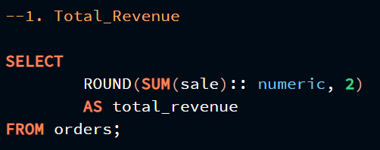

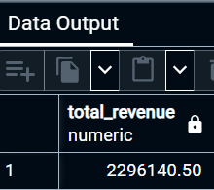

1. Average order value =

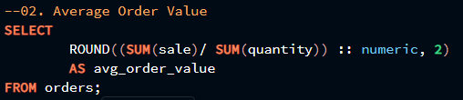

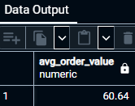

1. Total orders =

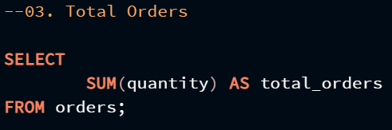

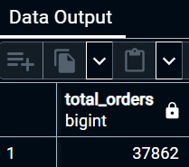

1. Average qty per order =

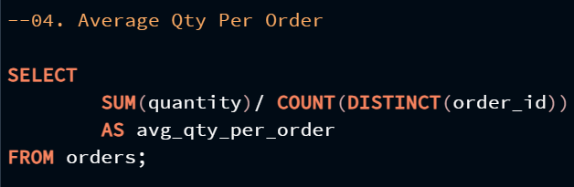

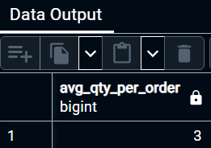

1. Average Price Per Unit =

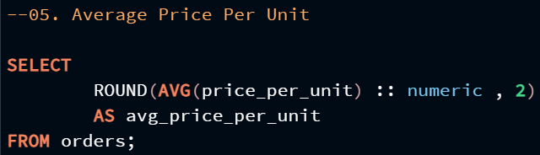

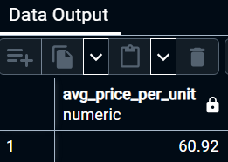

**ANALYSIS QUESTIONS RESOLVED-**

During the analysis, the following key questions were addressed using SQL queries and data analysis techniques:

1. Identify the Most Active and Most Idle Month.

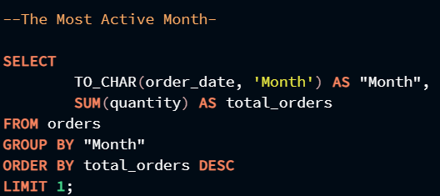

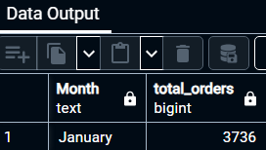

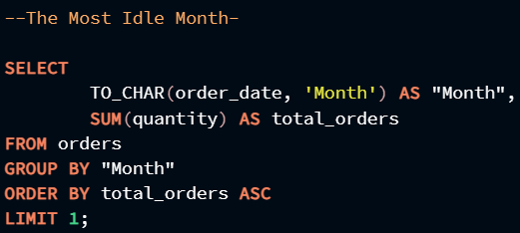

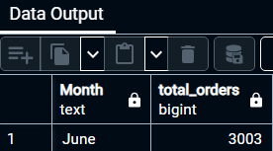

1. 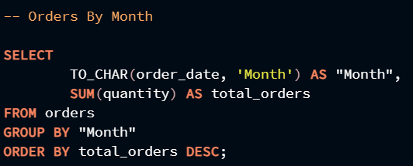Find out the month wise orders.

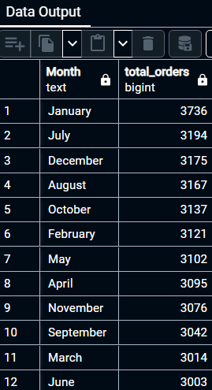

1. 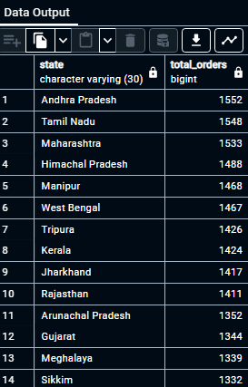Find out the orders by states.

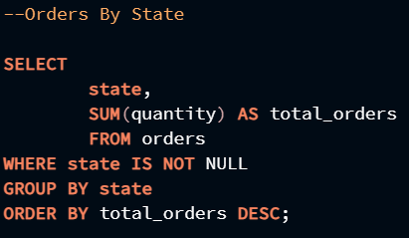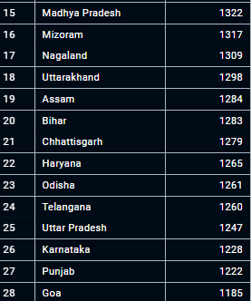

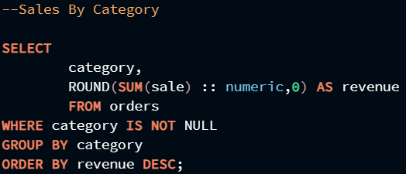

1. Find percentage of sales according to category.

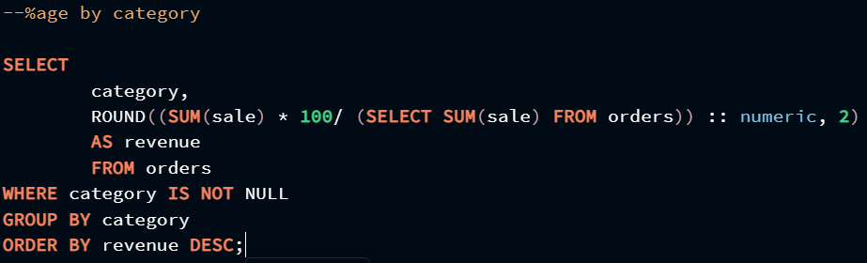

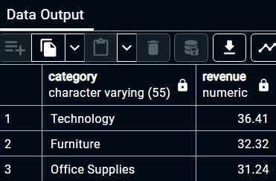

1. Find percentage of sales according to sub category.

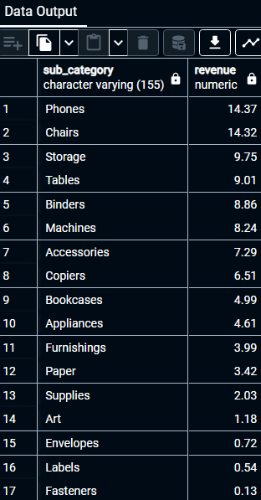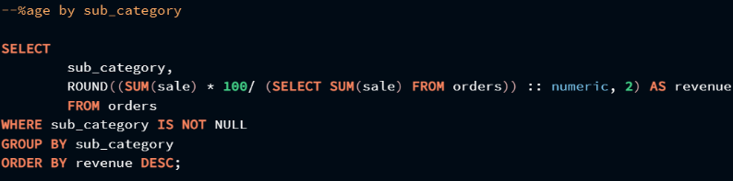

1. Find Out Best and Worst Seller Product.

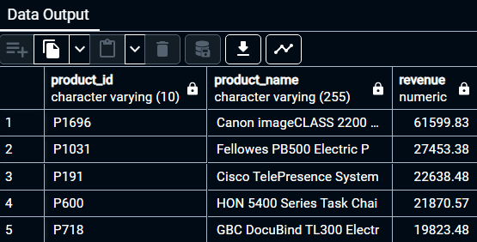

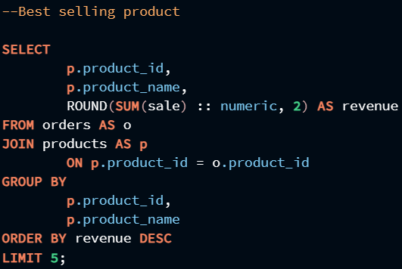

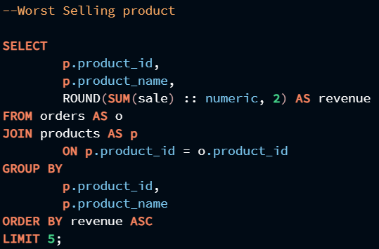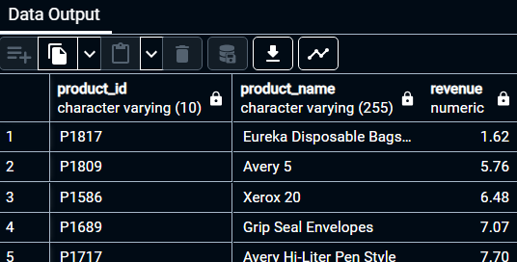

1. 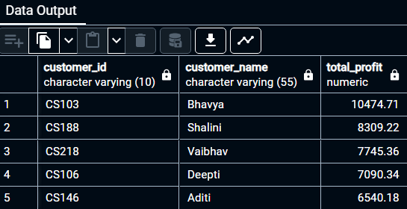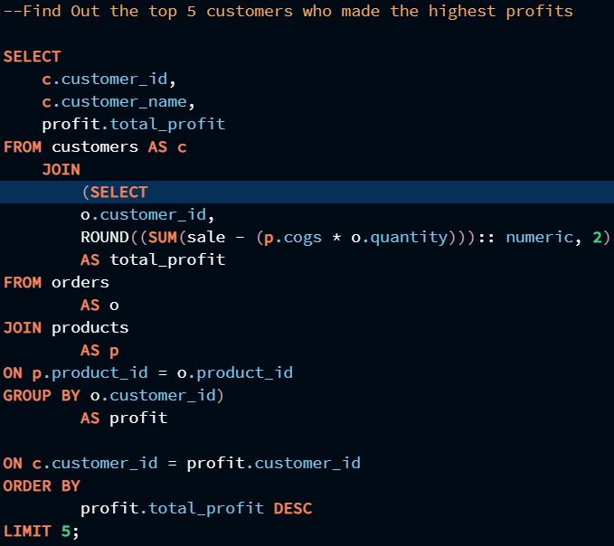Find out the top 5 customers who made the highest profits.
2. Find out the average quantity ordered per category.

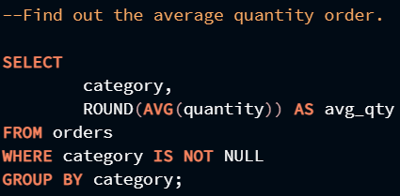 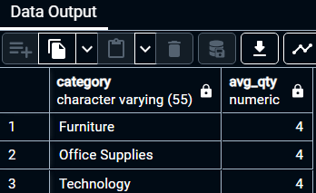

1. 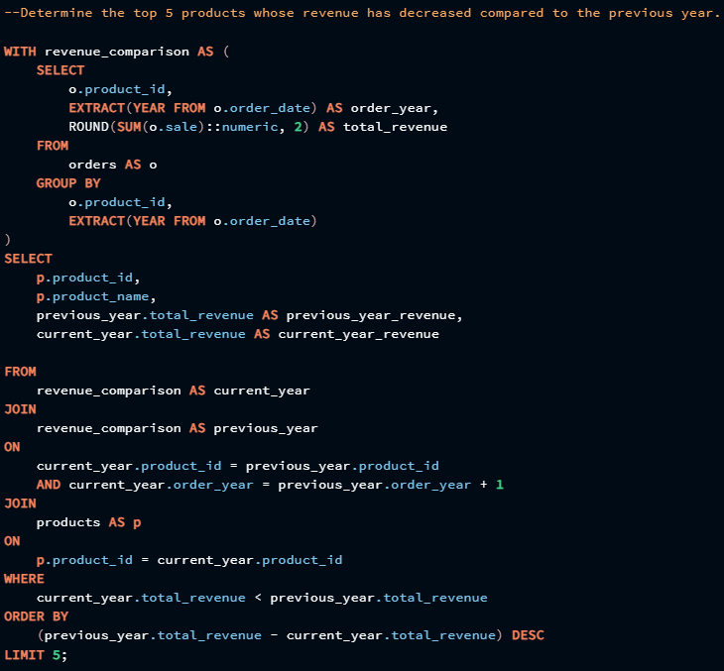Determine the top 5 products whose revenue has decreased compared to the previous year.

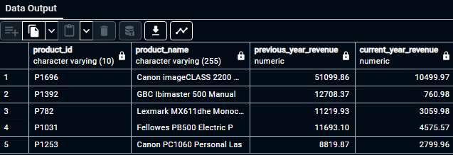

1. 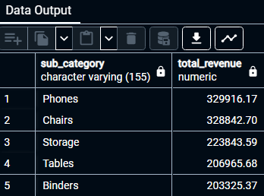 Identify the highest profitable sub-category.

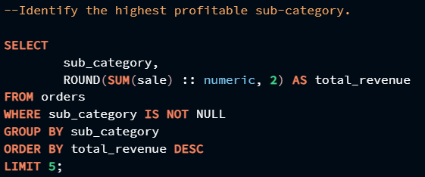

1. 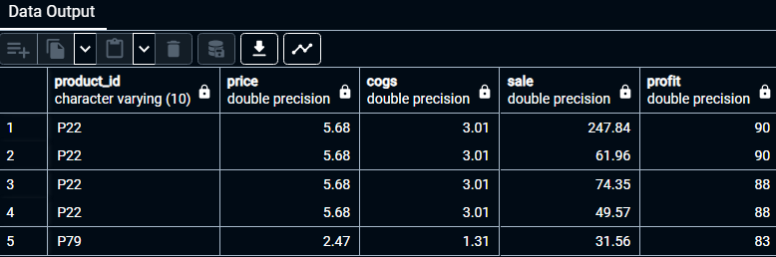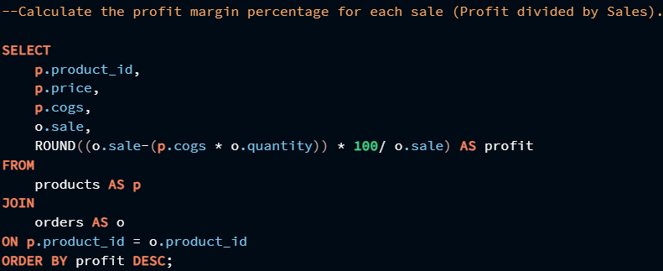Calculate the profit margin percentage for each sale (Profit divided by Sales).
2. Calculate the percentage contribution of each sub-category.

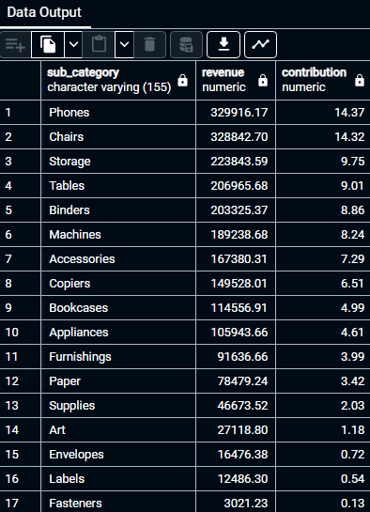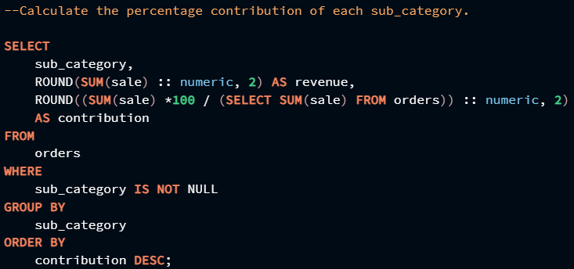

1. Identify the top 2 categories that have received maximum returns and their return percentage.

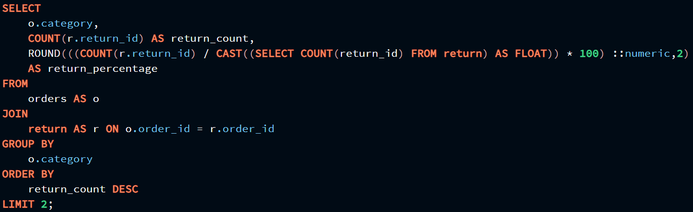

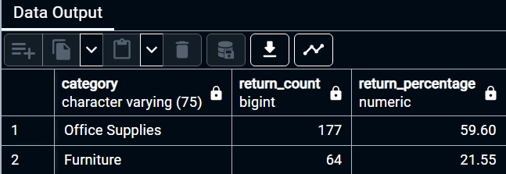

**Entity Relationship Diagram (ERD)**

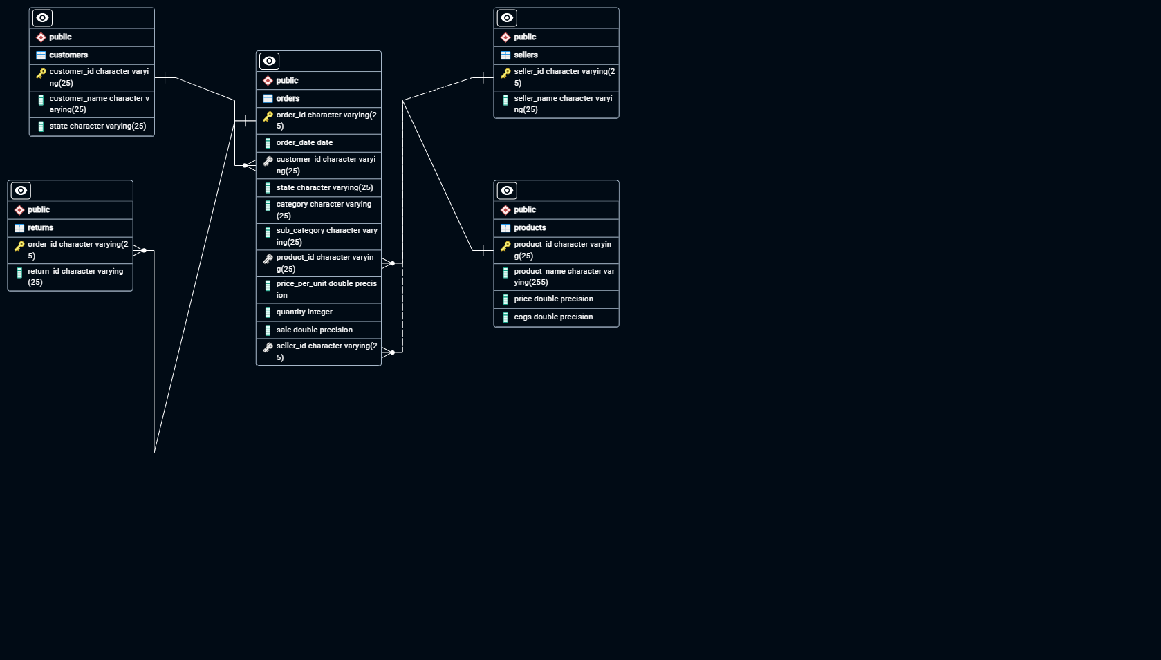

An Entity-Relationship Diagram (ERD) has been created to visualize the relationships between the tables in the dataset. This diagram provides a clear understanding of the data structure and helps in identifying key entities and their attributes.

**CONCLUSION –**

In conclusion, our project endeavours to offer meaningful insights into Amazon's sales patterns, customer inclinations, and various factors shaping e-commerce dynamics. By meticulously scrutinizing the dataset and delving into pivotal inquiries, our aim is to empower stakeholders with actionable intelligence, enabling them to make informed decisions and refine their sales strategies for optimal outcomes.